**Data Cleaning and Pre-Processing**

df = df.dropna()

df = df.drop_duplicates()

# Removing Unnecessary Columns

df = df[df["owner"] != "Test Drive Car"]

df.reset_index(drop=True, inplace=True)

df.head()

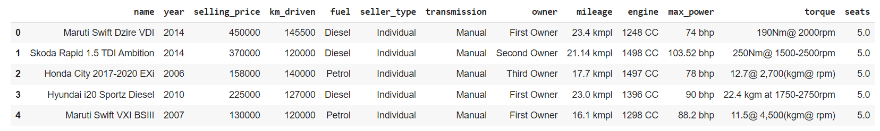

df.isna().sum()

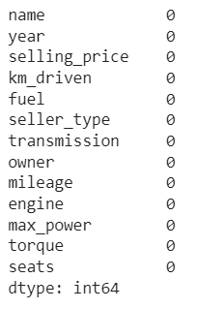

df.shape



df.info

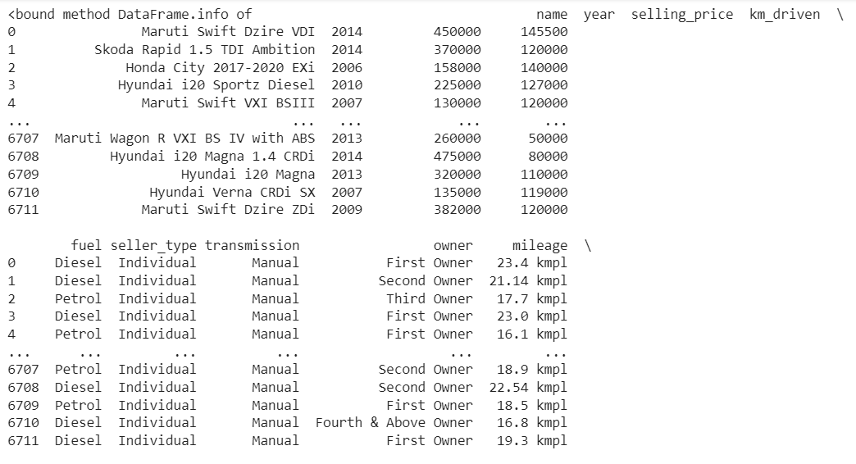

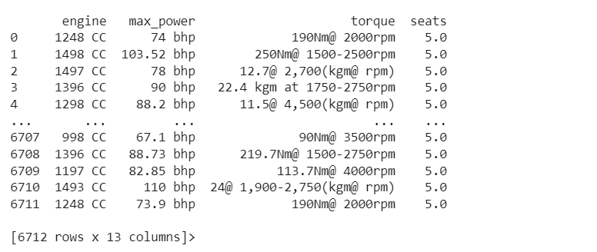

print(df["fuel"].value_counts())

print(df["seller_type"].value_counts())

print(df["transmission"].value_counts())

print(df["owner"].value_counts())

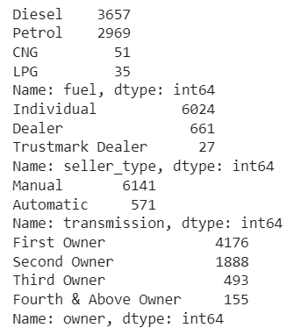

df['company']=df['name'].str.split().str.slice(start=0,stop=1).str.join(' ')

df.head()

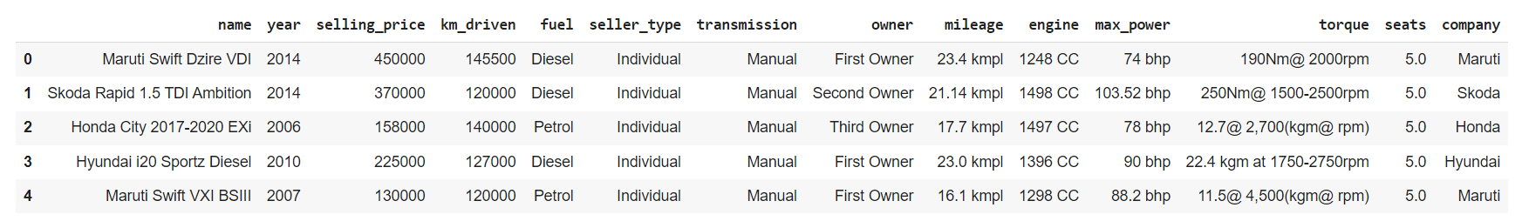

df.to_csv('cleaned_car_details.csv')